



New ismailia national university
Faculty of international trade and language
DMEB program
سوق إلكتروني مجتمعي للمزارعين (من المزرعة إلى باب المنزل)

Community Farmers’ E-Market (Farm-to-Door)
Graduation Project
Submitted to the
Faculty of Commerce, English Section
Business Information Systems
As a requirement for the graduation project course

Supervised by:
Dr./ Hassan El-Mahdy
Ismailia, Egypt
2025/2026

Community Farmer's E-Market
1 | Nada azoz mahmoud ahmed
2 | Amal Alaa El-Din Abu Bakr Imam
3 | Nada Mohamed El-Sayed Saad
4 | Yasmin El-Sayed Mohamed Abdel Fattah
5 | Menna allah ahmed farghaly mohamed
6 | Turkian Mohamed Sayed Mahmoud Mohamed
7 | Esraa Mohamed Abdel Moneim Mohamed El-Hady
8 | Micheal Milad Attia
9 | Hosny Mohamed Hosny
Team Work: -

Supervisor: Dr./ Hassan El-Mahdy

Acknowledgment

We would like to express our sincere appreciation to everyone who contributed to the successful completion of this graduation project.
First and foremost, we extend our deepest gratitude to Prof. Dr. Hassan Al-Mahdi for his continuous guidance, valuable feedback, and constant support throughout the analysis, development, and documentation stages of this project. His expertise and encouragement played a vital role in shaping the final outcome.
We also thank the faculty members and staff of the Department of Business Information Systems (BIS) at Suez Canal University for providing a strong academic foundation, practical knowledge, and an environment that promotes innovation and technical growth.
Special thanks are extended to our colleagues and classmates for their cooperation, constructive discussions, and moral support during the different phases of this work.
This project reflects the integration of information technology and business principles, which represents the core of the BIS discipline, and stands as an important milestone in our academic and professional journey.

Abstract
The Farmer Assistant Web Platform is a web-based system designed to support farmers in managing their agricultural activities more efficiently and effectively. The platform aims to address common challenges faced by farmers, such as tracking crops, calculating profits, managing subscriptions, and accessing clear analytical insights through a single, centralized system.
The platform provides a user-friendly interface for farmers to manage crop data, monitor stock levels, and calculate profits based on predefined pricing models, while administrators can oversee subscriptions, analyze revenue, and monitor overall system performance through a dedicated dashboard. The system is developed using modern web technologies to ensure security, scalability, and ease of use.
The first version of the platform successfully demonstrates core functionalities, including user authentication, crop management, subscription handling, and administrative analytics. This project highlights how digital transformation can enhance agricultural management and decision-making, offering a scalable solution that can be expanded in the future to include advanced analytics, mobile applications, and real-time data integration.

Table of Contents

Acknowledgment ..................................................... iii
Abstract ............................................................. iv

Chapter 1: Project Objectives ........................................................ 2
1.1 Introduction ............................................................................. 3
1.2 Aims and Objectives ................................................................. 4
1.3 Key Features of the Farmer Assistant Web Platform .............. 10
1.3.1 Farmer-Facing Features ....................................................... 10
1.3.2 Admin-Facing Features ........................................................ 11
1.3.3 User Roles and Access Control ............................................. 12
1.3.4 Cross-Cutting and Technical Features .................................. 12

Chapter 2: Introduction ................................................................ 14
2.1 Introduction ............................................................................ 15
2.1.1 Challenges in Traditional Agricultural Management Systems .. 15
2.1.2 Farmer Expectations and Sector Transformation ................ 16
2.1.3 The Need for Integrated, Data-Driven Platforms ................. 16
2.1.4 Limitations of Conventional Solutions .................................. 17
2.1.5 The Farmer Assistant Web Platform ..................................... 17
2.1.6 Core Technology Stack and Innovations ............................... 18
2.2 Problem Statement ................................................................. 19

Chapter 3: Project Requirements .................................................. 21
3.1 Introduction ............................................................................. 21
3.2 Programming Languages and Applications Used ..................... 24
3.2.1 TypeScript with React ........................................................... 24
3.2.2 JavaScript (Node.js with Express.js) ...................................... 25

3.2.3 HTML5 & CSS3 (Tailwind CSS) ..................................... 26
3.3 Applications and Development Tools ............................ 26
3.3.1 Visual Studio Code ...................................................... 26
3.3.2 MySQL ........................................................................ 27
3.3.3 Figma .......................................................................... 27
3.3.4 Vite ............................................................................. 28
3.3.5 Radix UI and Lucide React .......................................... 28

Chapter 4: The Proposed System ........................................ 30
4.1 Introduction .................................................................. 31
4.2 System Features Overview ........................................... 31
4.3 Login / Sign In Module .................................................. 32
4.4 Crop and Stock Management Module .......................... 34
4.5 Profit Calculation and Reporting .................................. 36
4.6 Admin Dashboard: System and Subscription Management .......... 37
4.7 Logout Module ............................................................. 38

Chapter 5: System Architecture and Design ......................... 39
5.1 Introduction ................................................... 39
5.2 Data Flow Diagram (DFD) ...................................... 41
5.3 Use Case Diagram .............................................. 43
5.4 Class Diagram ................................................ 45

Chapter 6: Implementation ......................................... 49
6.1 Introduction ................................................... 50
6.2 Core Features to Implement ................................... 50
6.3 Technical Implementation ..................................... 52
6.4 User Flow ..................................................... 55
6.5 Deployment Strategy .......................................... 56
6.6 Final Notes ................................................... 56

Chapter 7: Business Model ......................................... 57
7.1 Introduction ................................................... 58
7.1.1 Key Features ............................................... 61
7.1.2 Revenue Streams ............................................ 61
7.2 Marketing Plan ................................................ 61
7.2.1 Mission Statement .......................................... 61
7.2.2 Vision Statement ........................................... 62
7.2.3 Marketing Objectives ....................................... 62
7.2.4 User Personas .............................................. 63
7.2.5 Marketing Strategies ....................................... 63
7.2.6 Marketing Mix – The 4Ps .................................... 64
7.2.7 SWOT Analysis .............................................. 64
7.2.8 BCG Matrix ................................................. 65
7.2.9 Strategic Positioning ..................................... 65

Chapter 8: Future Plan ............................................ 66
8.1 Introduction ................................................... 67
8.2 Future Plan for the Farmer Assistant System .................. 67
8.3 Long-Term Vision .............................................. 71
8.4 Final Remarks ................................................. 71

Chapter 9: Conclusion and Recommendations ......................... 72
9.1 Conclusion ..................................................... 73
9.2 Recommendations .............................................. 74

List of References ................................................ 77

Chapter 1
Project Objectives

1.1 Introduction
This chapter, Project Objectives, serves as the foundational framework for the Farmer Assistant Web Platform, a web-based agricultural management system designed to support farmers through digital transformation. It presents a structured overview of the system’s purpose, scope, and functional delivery from both technical and business perspectives.
• Project Objectives:
This chapter begins by defining the core objectives that guide the development of the Farmer Assistant Web Platform. These objectives focus on digital crop management, automated profit calculation, subscription-based services, secure system access, administrative oversight, and scalability aligned with modern Business Information Systems (BIS) principles.
• Key Features Overview:
This section outlines the primary functionalities implemented in the first operational version of the system, categorized into:
Farmer-Facing Features: Including crop tracking, profit analytics, subscription management, notifications, and AI-powered assistance.
Admin-Facing Features: Such as farmer management, subscription monitoring, revenue and profit analytics, and system-level controls.
Cross-Cutting Features: Core technical aspects including authentication, authorization, database integrity, and performance considerations.
In summary, this chapter defines what the Farmer Assistant Web Platform is, clarifies its objectives, and establishes the technical and business requirements it fulfills within the agricultural sector.

1.2 Aims and Objectives
The Farmer Assistant Web Platform is designed to modernize agricultural management by integrating full-stack web technologies with data-driven analytics and structured administrative control. Grounded in Business Information Systems (BIS) concepts, the platform bridges technology and agriculture, targeting farmers who require efficient tools to manage crops, monitor profitability, and make informed decisions.

The following objectives are structured to ensure usability, system reliability, operational efficiency, and long-term scalability:
1. Digital Crop Management and Centralized Data Control
This chapter, Project Objectives, serves as the foundational framework for the Farmer Assistant Web Platform, a web-based agricultural management system designed to support farmers through digital transformation. It presents a structured overview of the system’s purpose, scope, and functional delivery from both technical and business perspectives.
• Project Objectives:
This chapter begins by defining the core objectives that guide the development of the Farmer Assistant Web Platform. These objectives focus on digital crop management, automated profit calculation, subscription-based services, secure system access, administrative oversight, and scalability aligned with modern Business Information Systems (BIS) principles.
• Key Features Overview:
This section outlines the primary functionalities implemented in the first operational version of the system, categorized into:
Farmer-Facing Features: Including crop tracking, profit analytics, subscription management, notifications, and AI-powered assistance.
Admin-Facing Features: Such as farmer management, subscription monitoring, revenue and profit analytics, and system-level controls.
Cross-Cutting Features: Core technical aspects including authentication, authorization, database integrity, and performance considerations.
In summary, this chapter defines what the Farmer Assistant Web Platform is, clarifies its objectives, and establishes the technical and business requirements it fulfills within the agricultural sector.
2. Automated Profit Calculation and Agricultural Analytics
This chapter, Project Objectives, serves as the foundational framework for the Farmer Assistant Web Platform, a web-based agricultural management system designed to support farmers through digital transformation. It presents a structured overview of the system’s purpose, scope, and functional delivery from both technical and business perspectives.
• Project Objectives:
This chapter begins by defining the core objectives that guide the development of the Farmer Assistant Web Platform. These objectives focus on digital crop management, automated profit calculation, subscription-based services, secure system access, administrative oversight, and scalability aligned with modern Business Information Systems (BIS) principles.
• Key Features Overview:
This section outlines the primary functionalities implemented in the first operational version of the system, categorized into:
Farmer-Facing Features: Including crop tracking, profit analytics, subscription management, notifications, and AI-powered assistance.
Admin-Facing Features: Such as farmer management, subscription monitoring, revenue and profit analytics, and system-level controls.
Cross-Cutting Features: Core technical aspects including authentication, authorization, database integrity, and performance considerations.
In summary, this chapter defines what the Farmer Assistant Web Platform is, clarifies its objectives, and establishes the technical and business requirements it fulfills within the agricultural sector.
3. Secure and Structured Subscription-Based Service Model
This chapter, Project Objectives, serves as the foundational framework for the Farmer Assistant Web Platform, a web-based agricultural management system designed to support farmers through digital transformation. It presents a structured overview of the system’s purpose, scope, and functional delivery from both technical and business perspectives.
• Project Objectives:
This chapter begins by defining the core objectives that guide the development of the Farmer Assistant Web Platform. These objectives focus on digital crop management, automated profit calculation, subscription-based services, secure system access, administrative oversight, and scalability aligned with modern Business Information Systems (BIS) principles.
• Key Features Overview:
This section outlines the primary functionalities implemented in the first operational version of the system, categorized into:
Farmer-Facing Features: Including crop tracking, profit analytics, subscription management, notifications, and AI-powered assistance.
Admin-Facing Features: Such as farmer management, subscription monitoring, revenue and profit analytics, and system-level controls.
Cross-Cutting Features: Core technical aspects including authentication, authorization, database integrity, and performance considerations.
In summary, this chapter defines what the Farmer Assistant Web Platform is, clarifies its objectives, and establishes the technical and business requirements it fulfills within the agricultural sector.
4. Comprehensive Administrative Control and Business Intelligence
This chapter, Project Objectives, serves as the foundational framework for the Farmer Assistant Web Platform, a web-based agricultural management system designed to support farmers through digital transformation. It presents a structured overview of the system’s purpose, scope, and functional delivery from both technical and business perspectives.
• Project Objectives:
This chapter begins by defining the core objectives that guide the development of the Farmer Assistant Web Platform. These objectives focus on digital crop management, automated profit calculation, subscription-based services, secure system access, administrative oversight, and scalability aligned with modern Business Information Systems (BIS) principles.
• Key Features Overview:
This section outlines the primary functionalities implemented in the first operational version of the system, categorized into:
Farmer-Facing Features: Including crop tracking, profit analytics, subscription management, notifications, and AI-powered assistance.
Admin-Facing Features: Such as farmer management, subscription monitoring, revenue and profit analytics, and system-level controls.
Cross-Cutting Features: Core technical aspects including authentication, authorization, database integrity, and performance considerations.
In summary, this chapter defines what the Farmer Assistant Web Platform is, clarifies its objectives, and establishes the technical and business requirements it fulfills within the agricultural sector.
5. Secure, Accessible, and Performant System Architecture
This chapter, Project Objectives, serves as the foundational framework for the Farmer Assistant Web Platform, a web-based agricultural management system designed to support farmers through digital transformation. It presents a structured overview of the system’s purpose, scope, and functional delivery from both technical and business perspectives.
• Project Objectives:
This chapter begins by defining the core objectives that guide the development of the Farmer Assistant Web Platform. These objectives focus on digital crop management, automated profit calculation, subscription-based services, secure system access, administrative oversight, and scalability aligned with modern Business Information Systems (BIS) principles.
• Key Features Overview:
This section outlines the primary functionalities implemented in the first operational version of the system, categorized into:
Farmer-Facing Features: Including crop tracking, profit analytics, subscription management, notifications, and AI-powered assistance.
Admin-Facing Features: Such as farmer management, subscription monitoring, revenue and profit analytics, and system-level controls.
Cross-Cutting Features: Core technical aspects including authentication, authorization, database integrity, and performance considerations.
In summary, this chapter defines what the Farmer Assistant Web Platform is, clarifies its objectives, and establishes the technical and business requirements it fulfills within the agricultural sector.
6. Academic and Professional Development Through Applied Learning
This chapter, Project Objectives, serves as the foundational framework for the Farmer Assistant Web Platform, a web-based agricultural management system designed to support farmers through digital transformation. It presents a structured overview of the system’s purpose, scope, and functional delivery from both technical and business perspectives.
• Project Objectives:
This chapter begins by defining the core objectives that guide the development of the Farmer Assistant Web Platform. These objectives focus on digital crop management, automated profit calculation, subscription-based services, secure system access, administrative oversight, and scalability aligned with modern Business Information Systems (BIS) principles.
• Key Features Overview:
This section outlines the primary functionalities implemented in the first operational version of the system, categorized into:
Farmer-Facing Features: Including crop tracking, profit analytics, subscription management, notifications, and AI-powered assistance.
Admin-Facing Features: Such as farmer management, subscription monitoring, revenue and profit analytics, and system-level controls.
Cross-Cutting Features: Core technical aspects including authentication, authorization, database integrity, and performance considerations.
In summary, this chapter defines what the Farmer Assistant Web Platform is, clarifies its objectives, and establishes the technical and business requirements it fulfills within the agricultural sector.

Key Features of the Farmer Assistant Web Platform
The Farmer Assistant Web Platform is a full-stack web application designed to support agricultural operations through modern technologies, structured analytics, and secure access control. The system architecture emphasizes scalability, data integrity, and extensibility, with all core features implemented in the initial release.

1.3.1 Farmer-Facing Features
Crop Management and Tracking
- Add, edit, delete, and view crop records.
- Store crop quantities, stock levels, and pricing details.
- Real-time updates reflecting inventory changes.
Profit and Performance Analytics
- Automated calculation of crop revenue and profit.
- Visual dashboards summarizing financial performance.
- Historical profit tracking per crop.
User Dashboard
- Centralized overview of crops, profits, and subscription status.
- Notifications for low stock and subscription expiration.
- Personalized farmer experience.
AI-Powered Assistant
- Chat-based interface for guidance and system support.
- Answers common farming and system-related queries.
- Assists users in navigating features and understanding analytics.
Account and Profile Management
- Secure login and registration.
- Profile editing and password updates.
- Persistent user sessions.

1.3.2 Admin-Facing Features (Implemented in v1.0)
Farmer and Subscription Management
- View all registered farmers.
- Track subscription plans and statuses.
- Separate views for subscription revenue and crop profit.
Analytics and Reporting
- Total revenue from subscriptions.
- Total profit from crops.
- Subscription plan distribution analytics.
System Monitoring
- Activity tracking for user actions.
- Platform-wide performance insights.
- Data consistency and integrity checks.

1.3.3 User Roles and Access Control
- Farmer Role:
  - Manage own crops
  - View analytics
  - Manage subscriptions
- Admin Role:
  - Full system access
  - View all data and analytics
  - Manage users and subscriptions
Role-based middleware ensures secure access to protected routes and functionalities.

1.3.4 Cross-Cutting and Technical Features
Security
- JWT-based authentication.
- Encrypted password storage using bcrypt.
- Protected API endpoints.
- Input validation and SQL injection prevention.
Performance and Scalability
- Optimized database queries with indexing.
- Modular backend architecture
- Scalable frontend component design.
Extensibility
- Ready for future integrations such as:
  - Payment gateways
  - Weather APIs
  - Market price APIs
  - Mobile applications

Chapter 2
Introduction

2.1 Introduction
Agriculture represents one of the most vital sectors of the Egyptian economy, standing at the intersection of food security, economic stability, and sustainable development. Despite its importance, agricultural practices in many regions continue to rely on traditional, manual methods for crop management, financial tracking, and decision-making. As digital transformation accelerates across industries, agriculture increasingly demands intelligent, reliable, and data-driven systems capable of supporting farmers in both operational and strategic aspects of their work.
With the growth of web-based technologies and mobile access, farmers now expect digital tools that simplify daily operations, provide clear insights, and support informed decision-making. However, agricultural management systems must address unique challenges related to crop variability, pricing fluctuations, inventory tracking, and financial transparency—requirements that extend beyond generic management software.

2.1.1 Challenges in Traditional Agricultural Management Systems
In many farming environments, operational data is still recorded manually using notebooks, spreadsheets, or informal methods. These approaches present several challenges:
Fragmented and inconsistent data records.
Difficulty in tracking crop quantities, stock levels, and performance over time.
High risk of human error in calculations related to yield and profit.
Lack of centralized systems to support long-term planning and analysis.
Such limitations prevent farmers from gaining a clear overview of their operations and reduce their ability to respond effectively to market changes or operational risks.
2.1.2 Farmer Expectations and Sector Transformation
Modern farmers—particularly younger and technology-aware generations—are increasingly seeking digital solutions that simplify management tasks and improve productivity. Beyond basic record-keeping, farmers expect systems that:
Provide real-time insights into crop performance.
Automate financial calculations such as revenue and profit.
Offer intuitive dashboards that present complex data in a clear and actionable form.
Support bilingual access to accommodate diverse user backgrounds.
This shift reflects a broader transformation toward smart agriculture, where data, automation, and analytics play a central role in improving efficiency and sustainability.

2.1.3 The Need for Integrated, Data-Driven Agricultural Platforms
At the core of agricultural digitalization lies the need for integrated systems that unify operational data and analytical insights. An effective agricultural management platform must combine:
Centralized crop and inventory tracking.
Automated profit and revenue calculations.
Secure user authentication and role-based access.
Subscription-based service models to ensure system sustainability.
Administrative analytics for monitoring platform performance.
Equally important, such systems must empower administrators and decision-makers, ensuring that technological innovation enhances both user experience and operational control.

2.1.4 Limitations of Conventional Solutions
Despite the availability of some agricultural and management tools, many existing solutions exhibit clear limitations:
A. Rigidity and Limited Customization
Off-the-shelf management systems often provide fixed workflows that cannot be easily adapted to the specific needs of farmers. These systems lack flexibility in crop categorization, pricing models, and profit calculation logic, making them unsuitable for diverse agricultural contexts.
B. Technical and Structural Weaknesses
Other platforms suffer from weak system architecture, including:
Poor separation between frontend and backend layers.
Inconsistent data validation and error handling.
Limited security measures for protecting sensitive user data.
Such technical shortcomings reduce system reliability, limit scalability, and hinder long-term adoption.

2.1.5 The Farmer Assistant Web Platform
To address these challenges, this project introduces the Farmer Assistant Web Platform—a full-stack, web-based agricultural management system designed to support farmers through intelligent automation and structured analytics.
Developed in alignment with Business Information Systems (BIS) principles, the platform bridges agricultural practice with modern software engineering. It is not merely a data entry tool, but an integrated digital solution aimed at enhancing productivity, financial awareness, and decision-making across farming operations.

2.1.6 Core Technology Stack and Innovations
The platform is built using a modern and reliable technology stack, including:
React (TypeScript)
Vite
Tailwind CSS and Radix UI
Node.js with Express.js
MySQL relational database
This stack ensures performance, security, accessibility, and maintainability.
Key innovations of the Farmer Assistant Web Platform include:
Digital crop management, enabling farmers to track quantities, stock levels, and crop details in real time.
Automated profit calculation, based on predefined pricing and cost models, reducing human error and increasing financial clarity.
AI-powered assistance, providing guidance and support for system usage and farming-related queries.
Comprehensive admin dashboards, offering insights into subscriptions, revenue, and crop profit analytics.
Bilingual user interface (English and Arabic) with full RTL support, ensuring accessibility for a wider user base.
By replacing fragmented, manual processes with a unified and data-driven platform, the Farmer Assistant Web Platform demonstrates how modern web technologies can enhance agricultural management—transforming traditional practices into efficient, scalable, and intelligent systems.

2.2 Problem Statement
Despite advancements in digital technology, many farmers continue to face significant challenges due to the absence of dedicated agricultural management platforms. Common issues include:
Lack of Centralized Data: Crop records, inventory details, and financial data are scattered across multiple sources, making analysis difficult.
Manual Profit Calculation: Farmers often rely on manual calculations, which are time-consuming and prone to errors.
Limited Access to Analytics: Existing solutions do not provide clear insights into crop performance or profitability.
Subscription and Service Management Issues: Farmers lack structured systems for accessing and managing digital agricultural services.
Administrative Inefficiency: Platform administrators often lack unified tools for monitoring users, subscriptions, and overall system performance.
These challenges are further intensified by technical and usability limitations:
Inadequate security mechanisms risk exposing sensitive data.
Poor user experience discourages adoption among non-technical users.
Lack of bilingual support restricts accessibility in multilingual environments.
In an industry where efficiency, accuracy, and sustainability are critical, these shortcomings directly impact productivity and economic outcomes. To overcome these issues, this project proposes the Farmer Assistant Web Platform—a purpose-built, academically grounded system that redefines agricultural management through secure architecture, intelligent analytics, and user-centered design.

Chapter 3
Project Requirements

3.1 Introduction
With the rapid evolution of digital commerce, traditional e-commerce platforms are no longer sufficient to meet the expectations of modern consumers—particularly in premium, high-involvement markets such as eyewear. Conventional systems often rely on static product catalogs, limited personalization options, and generic customer support, which fail to replicate the confidence, expertise, and tailored guidance offered in physical optical stores. As a result, the online eyewear purchasing journey frequently feels fragmented, impersonal, and uncertain.
Today’s consumers—especially digitally native generations such as Millennials and Gen Z—expect more than basic online convenience. They seek personalized experiences, intelligent assistance, and brands that understand their preferences and lifestyles. This shift in consumer behavior has contributed to the rise of premium Direct-to-Consumer (DTC) eyewear brands, where companies such as Warby Parker have demonstrated the viability of digital-first retail models. However, even these pioneers face increasing pressure to innovate beyond static product listings and traditional home try-on programs toward adaptive, AI-driven, and highly personalized shopping experiences.
At the core of this transformation lies data-driven personalization and human-centered design. Modern e-commerce systems must seamlessly integrate real-time inventory management, secure transactional workflows, dynamic product customization, and responsive customer support within a unified, accessible, and high-performance interface. Equally important, these systems must empower business operators by providing actionable insights, operational control, and scalability—ensuring that technological innovation enhances both user experience and business efficiency.
The limitations of conventional e-commerce solutions are increasingly apparent. Many platforms rely on off-the-shelf systems such as Shopify or WooCommerce, which offer rigid templates and limited extensibility, making deep personalization, custom logic, or AI integration difficult without costly plugins or third-party dependencies. Other systems suffer from fragmented architectures, inconsistent state management, and inadequate security practices, resulting in technical debt that restricts scalability, performance, and long-term competitiveness.
To address these challenges, this project introduces EyeMatch Solution, a full-stack, AI-enhanced e-commerce platform designed specifically for the premium eyewear market. Developed under the principles of Business Information Systems (BIS), EyeMatch Solution integrates modern software engineering with strategic retail innovation. Rather than functioning as a simple online store, it is a comprehensive system built to deliver precision, personalization, and trust across the entire customer journey.
The platform is implemented using a modern technology stack—including React 18 (TypeScript), Vite, Radix UI, Express.js, and MySQL—to ensure performance, accessibility, scalability, and maintainability.
Key innovations of the system include:
- Real-time product customization, enabling users to engrave text and modify frame colors with instant visual feedback.
- The EyeMatch AI Stylist™, a rule-based intelligent assistant that supports order tracking, style-based recommendations, and interactive guidance without relying on external large language models, ensuring reliability and data privacy compliance.
- A comprehensive administrative dashboard that allows managers to control products, inventory, orders, and analytics through a unified interface.
- A dark-mode-first, WCAG-compliant user interface, optimized for visual comfort, accessibility, and extended browsing sessions.
By replacing fragmented and template-driven solutions with a cohesive, academically structured software system, EyeMatch Solution demonstrates how modern full-stack development can elevate the digital eyewear experience—transforming uncertainty into confidence and transactions into long-term customer relationships.

3.2 Programming Languages and Applications Used
This section presents the core programming languages, frameworks, and applications used in developing EyeMatch Solution. Each technology was carefully selected to support performance, scalability, maintainability, and a user-centered design approach. The documented stack also ensures that future developers can easily understand the system architecture and extend the platform with minimal friction.

3.2.1 TypeScript with React 18
Purpose:
TypeScript, a strongly typed superset of JavaScript, is used as the primary language for frontend development. When combined with React 18, it enables the creation of a scalable, component-based user interface with enhanced reliability and maintainability.
Reasons for Using React with TypeScript:
- Promotes reusable and modular UI components.
- Provides compile-time type checking to reduce runtime errors.
- Offers a mature ecosystem with extensive tooling and community support.
- Ensures high performance through React’s virtual DOM and concurrent rendering features.
Role in EyeMatch Solution:
Responsible for product browsing, real-time customization, cart and checkout flows, AI Stylist™ interaction, and administrative dashboards.

3.2.2 JavaScript (Node.js with Express.js)
Purpose:
JavaScript, through Node.js and Express.js, is used to implement the backend RESTful API.
Why Express.js:
- Lightweight and flexible framework.
- Rich middleware ecosystem.
- High performance and scalability.
- Seamless integration with TypeScript.
Role in EyeMatch Solution:
Manages authentication, product and inventory APIs, order processing, business logic, and AI Stylist™ operations.

3.2.3 HTML5 & CSS3 (with Tailwind CSS)
Purpose:
HTML5 provides semantic structure, while CSS3 and Tailwind CSS deliver the visual presentation layer.
Why Tailwind CSS:
- Utility-first approach for rapid development.
- Built-in dark mode support.
- Responsive design by default.
- Accessibility-friendly styling.
Role:
Controls layouts, UI components, customization panels, and the AI chat interface.

3.3 Applications and Development Tools
3.3.1 Visual Studio Code (VS Code)
Purpose:
Primary integrated development environment (IDE).
Role:
- Code editing with TypeScript and JavaScript support.
- Integrated terminal and Git version control.
- Productivity extensions such as ESLint, Prettier, and Tailwind IntelliSense.

3.3.2 MySQL (via mysql2 Driver)
Purpose:
Relational database management system used for persistent data storage.
Why MySQL:
- ACID compliance and relational integrity.
- High performance and scalability.
- Native JSON support.
- Cost-effective and widely supported.
Role:
Stores user accounts, products, orders, inventory records, sessions, and analytical data for administrative reporting.

3.3.3 Figma
Purpose:
UI/UX design and prototyping tool.
Role:
- Design of dark-mode interface system.
- Component libraries and layout standards.
- Interactive prototypes for usability validation.
- Efficient design-to-development handoff.

3.3.4 Vite
Purpose:
Frontend build and development tool.
Reasons for Selection:
- Extremely fast hot module replacement (HMR).
- Optimized production builds.
- First-class TypeScript support.
Role:
Ensures fast development cycles and optimal application load times.

3.3.5 Radix UI and Lucide React
Purpose:
Accessible UI component primitives and iconography.
Why Radix UI:
- Built-in accessibility support.
- Unstyled, flexible components.
- Composition-friendly architecture.
Role:
Forms the foundation for over 40 reusable interface components across the platform.

3.3.6 OpenRouter (Model: Amazon Nova 2 Lite)
Purpose:
To enhance personalization and intelligent assistance within the platform.
Why OpenRouter:
- Unified API for multiple AI models.
- Simplified backend integration.
- Flexible model selection.
Why Amazon Nova 2 Lite:
- Efficient performance with large token capacity.
Role in EyeMatch Solution:
- Powers the AI Stylist™ assistant.
- Interprets style quizzes and user preferences.
- Supports intelligent chat-based assistance and recommendation logic.

Chapter 4
The proposed Project
Eye Match

4.1 Introduction
The Farmer Assistant Web Platform is a modern, full-stack information system designed to support farmers in managing their agricultural activities efficiently and intelligently. The platform provides farmers with digital tools to manage crops, track profits, receive notifications, and locate nearby agricultural services, while offering administrators centralized control over users, subscriptions, and system data.
This chapter presents a detailed overview of the proposed system by describing its core features and main functional modules. These modules include user authentication, crop and stock management, profit calculation, subscription handling, map-based location services, notification alerts, and secure logout. Each module is designed to ensure system reliability, ease of use, data accuracy, and operational efficiency while maintaining appropriate security and scalability standards.
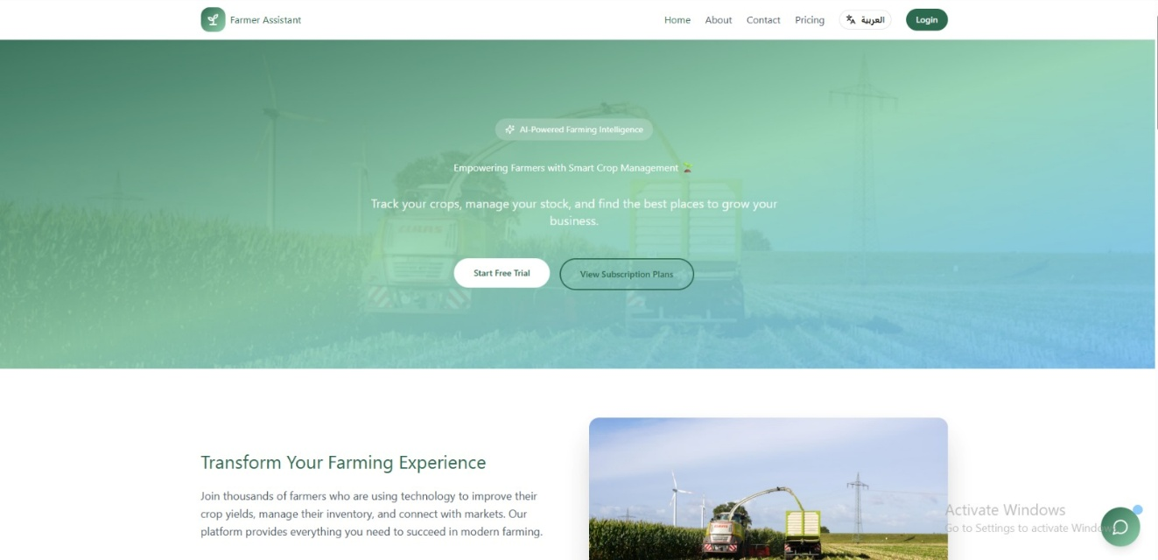

4.2 System Features Overview
The Farmer Assistant Web Platform integrates a set of essential features that work together to provide a reliable and user-friendly digital environment for agricultural management:
- Secure Login and Role-Based Access Control
o Secure authentication with encrypted passwords and controlled access for farmers and administrators.
- Crop and Stock Management
o Tools for adding crops, updating stock quantities, and monitoring crop availability in real time.
- Profit Calculation and Reporting
o Automatic calculation of profits based on crop data, costs, and sales inputs.
- Notification and Alert System
o Real-time alerts for low stock levels, critical conditions, and important system updates.
- Map and Location Services
o Integration with map services to help farmers find nearby suppliers, markets, and service locations.
Together, these features enhance transparency, decision-making, and productivity while supporting sustainable agricultural operations.

4.3 Login / Sign In Module
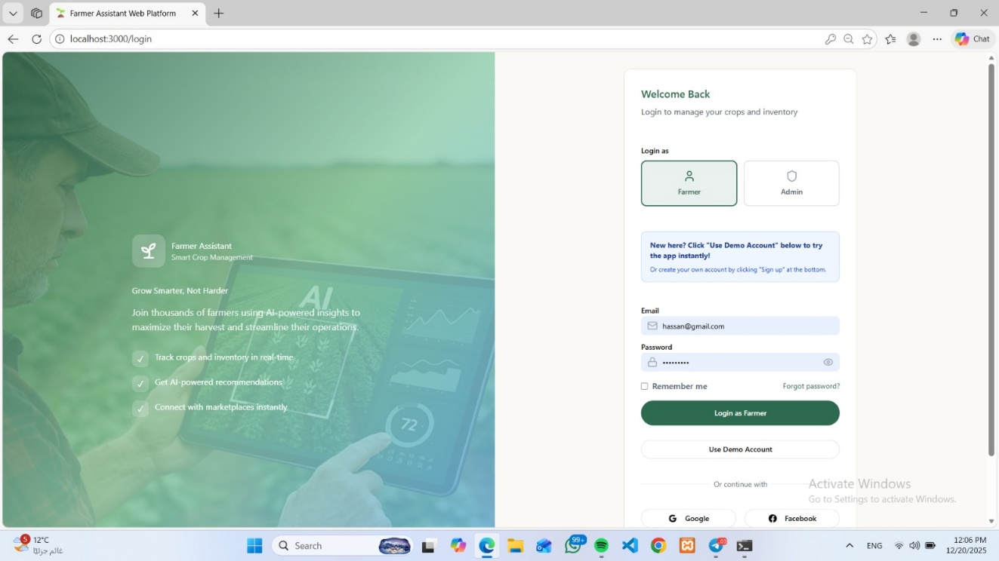
The Login / Sign In module serves as the secure entry point to the Farmer Assistant Web Platform, ensuring that only authorized users can access system features and sensitive data.

4.3.1 Security Mechanisms
• JWT (JSON Web Tokens) are used for user authentication.
• User passwords are securely hashed using modern encryption algorithms.
• Login credentials are never stored in plain text.
• Every protected request requires token validation.
• Protection against unauthorized access, session hijacking, and brute-force attacks.

4.3.2 Authentication Process
• Users authenticate through a secure login endpoint using email and password.
• Upon successful authentication, a JWT is generated containing:
o User ID
o Email
o User role (Farmer or Admin)
• The system supports automatic role assignment based on account type.

4.3.3 Role-Based Access Control
The platform defines two main user roles:
• Farmers
o Manage personal profiles, crops, stock levels, profits, subscriptions, and notifications.
• Administrators
o Manage farmer accounts, subscription plans, notifications, and system settings.
Access control is enforced on two levels:
• Backend: Middleware validates user roles before granting access to restricted endpoints.
• Frontend: System interfaces are dynamically displayed based on user permissions.

4.3.4 Account Management and Usability
• Users can update personal profile information.
• The system architecture supports future password recovery features.
• Secure logout removes authentication tokens from the client and server.
• Clean, user-friendly interface with form validation to reduce input errors.

4.4 Crop and Stock Management Module
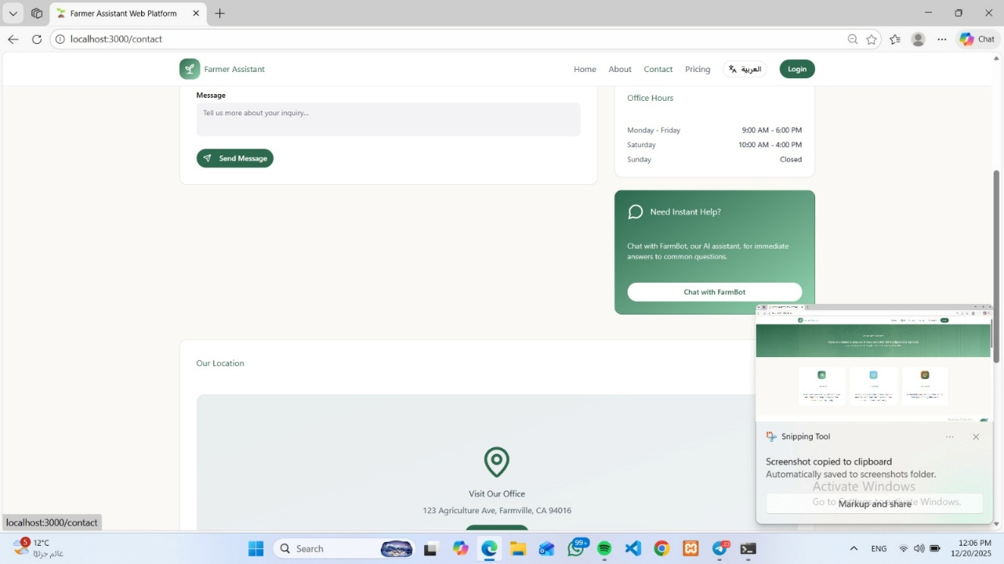
Crop and stock management is a core component of the Farmer Assistant Web Platform, enabling farmers to digitally organize and monitor their agricultural assets.

4.4.1 Crop Management Features
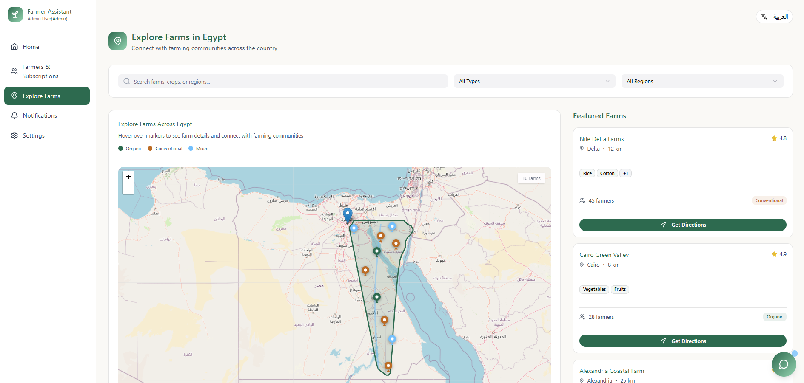
• Add new crops with details such as name, type, quantity, and cost.
• Update crop stock levels based on production or sales.
• View current stock status in real time.
• Store crop history for future analysis.

4.4.2 Technical Implementation
• Frontend: Dynamic forms and real-time updates using state management.
• Backend: Crop data is validated and processed through secure APIs.
• Database: Dedicated tables store crop details, quantities, and timestamps.

4.4.3 Business and Operational Impact
• Improves inventory accuracy.
• Reduces manual record-keeping errors.
• Enables better planning and resource allocation.
• Supports data-driven agricultural decisions.

4.5 Profit Calculation and Reporting
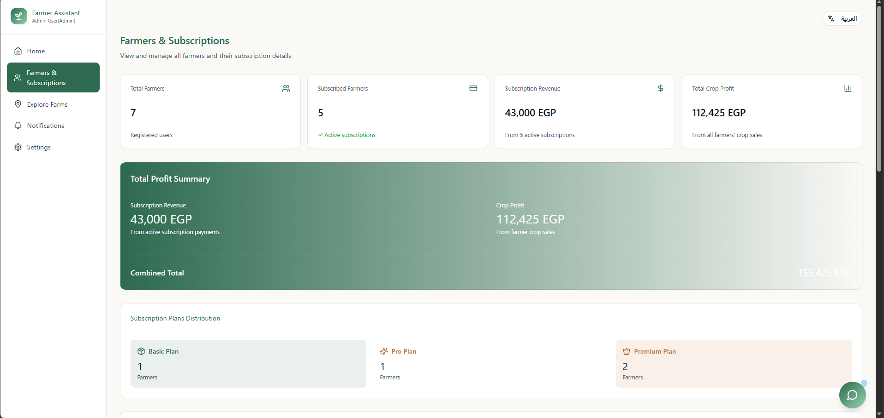
The platform provides an automated profit calculation module to help farmers understand the financial performance of their crops.

4.5.1 Profit Calculation Process
• Profits are calculated based on crop costs, quantities, and sales values.
• Reports are generated automatically when data is updated.
• Results are displayed in a clear and readable format.

4.5.2 User Benefits and Reliability
• Reduces dependency on manual calculations.
• Provides instant financial insights.
• Ensures data accuracy through validated inputs.
• Supports future export of financial reports.

4.6 Admin Dashboard: System and Subscription Management
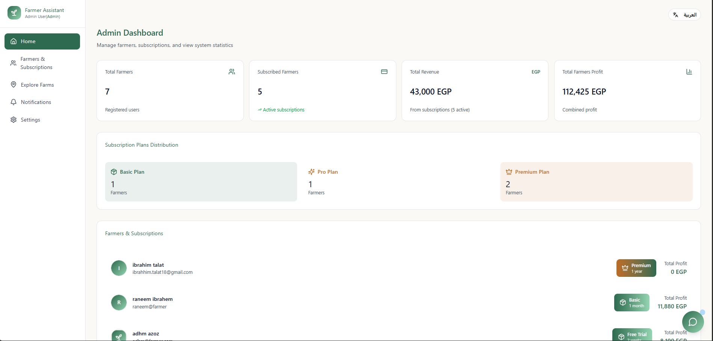
The Admin Dashboard acts as the control center for managing the overall platform.

4.6.1 Farmer and Subscription Management
Administrators can:
• View and manage farmer accounts.
• Create and update subscription plans.
• Monitor subscription status and usage.

4.6.2 Notifications and System Control
• Send system-wide notifications to farmers.
• Manage alert thresholds for stock levels.
• Monitor system activity and performance.

4.6.3 Security and Monitoring
• All admin actions require valid authentication tokens.
• Administrative activities are logged with timestamps.
• Ensures accountability and system integrity.

4.7 Logout Module
The Logout module ensures the protection of user data and system security after session termination.

4.7.1 Security Measures
• Immediate removal of authentication tokens from the client.
• Server-side token invalidation to prevent reuse.

4.7.2 Risk Prevention and Compliance
• Prevents unauthorized access on shared devices.
• Ensures complete removal of user privileges after logout.
• Prepares the system for compliance with data protection standards.

4.7.3 User Experience
• Clearly accessible logout option.
• Smooth redirection to the login or home page.
• Consistent and predictable system behavior after logout.

Chapter 5
System Architectu

5.4 Unified Modeling Language (UML) and System Diagrams
This section presents the visual models used to describe the structure and behavior of the Farmer Assistant Web Platform. The system is illustrated using a Data Flow Diagram (DFD), Use Case Diagram, and Class Diagram, each highlighting a different architectural perspective. Together, these diagrams provide a complete understanding of how data flows through the system, how users interact with its features, and how system components are structured internally.
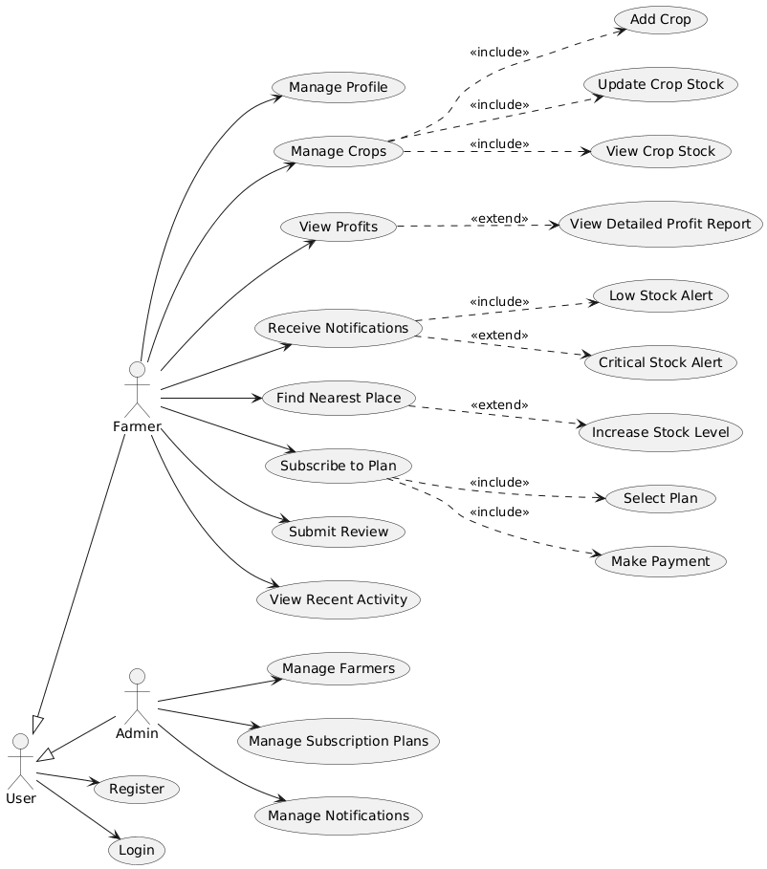

5.4.1 Data Flow Diagram (DFD)
The Data Flow Diagram (DFD) illustrates how data moves between users, system processes, and databases within the Farmer Assistant platform. It focuses on the logical flow of information rather than implementation details.
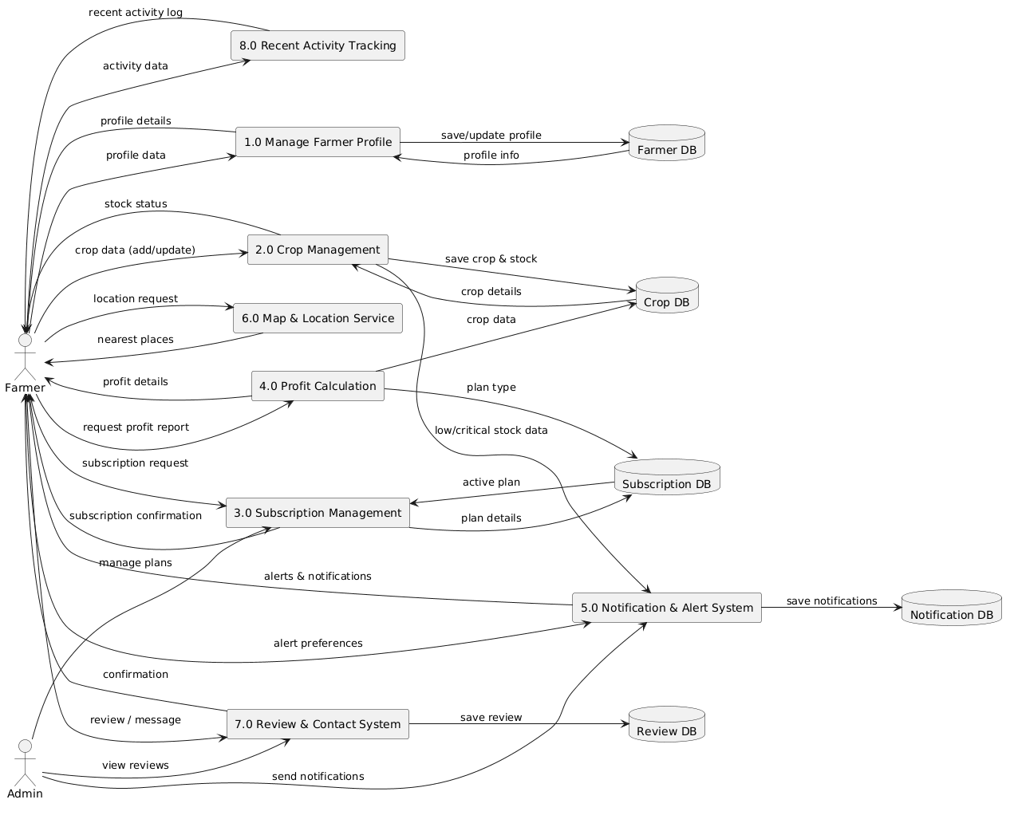

Actors:
- Farmer
- Admin

Main Processes:
- Manage Farmer Profile
Allows farmers to create and update their personal and farm-related information, which is stored in the Farmer Database.
- Crop Management
Enables farmers to add crops, update crop stock levels, and view crop details. All crop-related data is stored in the Crop Database.
- Subscription Management
Handles farmer subscription requests, plan selection, and subscription confirmation. Subscription data is stored in the Subscription Database.
- Profit Calculation
Calculates profits based on crop quantity, stock level, and pricing data. Profit reports are returned to the farmer upon request.
- Notification & Alert System
Generates alerts such as low-stock and critical-stock notifications. Notifications are stored in the Notification Database and delivered to farmers and admins.
- Map & Location Service
Allows farmers to find nearby locations such as markets or suppliers based on their geographic data.
- Review & Contact System
Enables farmers to submit feedback or reviews, which are stored in the Review Database and accessed by administrators.
- Recent Activity Tracking
Logs all major actions performed by users, allowing farmers and administrators to review recent activities.

Data Stores:
- Farmer DB
- Crop DB
- Subscription DB
- Notification DB
- Review DB
Figure 14 illustrates the Data Flow Diagram of the Farmer Assistant Web Platform, showing how information is processed and stored across system components.

5.4.2 Use Case Diagram
The Use Case Diagram represents the functional requirements of the system and illustrates interactions between actors and system features.

Actors:
- User (generic actor)
- Farmer
- Admin

Farmer Use Cases:
- Register and Login
- Manage Profile
- Manage Crops
  - Add Crop
  - Update Crop Stock
  - View Crop Stock
- View Profits
  - View Detailed Profit Report (extended use case)
- Receive Notifications
  - Low Stock Alert
  - Critical Stock Alert
- Find Nearest Place
- Subscribe to Plan
  - Select Plan
  - Make Payment
- Submit Review
- View Recent Activity

Admin Use Cases:
- Manage Farmers
- Manage Subscription Plans
- Manage Notifications

Relationships:
- <<include>> is used where authentication or sub-actions are mandatory
- <<extend>> is used for optional or conditional behavior (e.g., detailed profit reports or critical alerts)
Figure 15 presents the Use Case Diagram, demonstrating how farmers and administrators interact with the system’s features.

5.4.3 Class Diagram
The Class Diagram illustrates the internal structure of the Farmer Assistant system by defining system classes, their attributes, methods, and relationships.

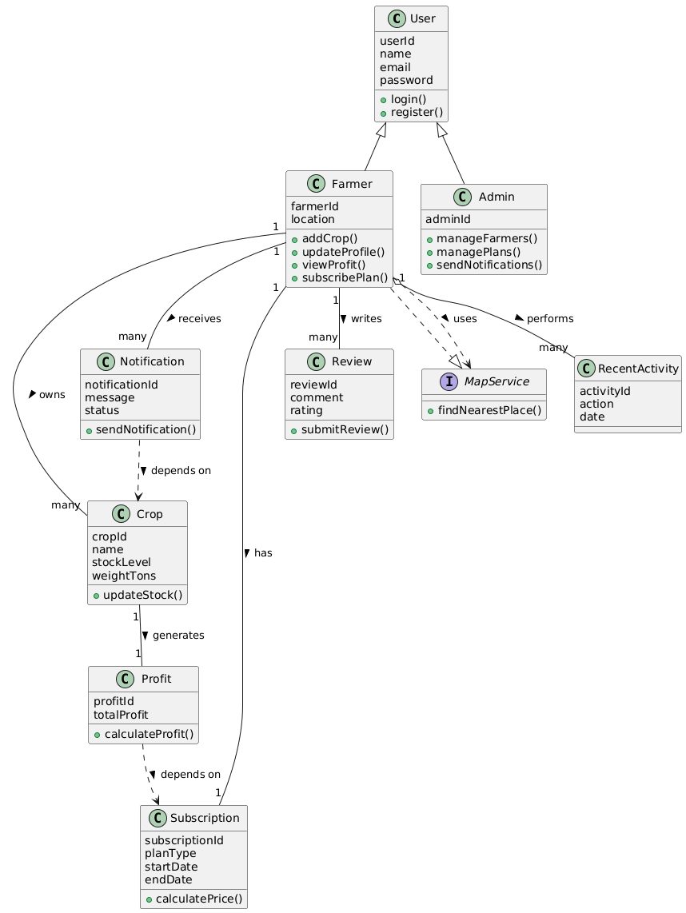

Main Classes:

1. User
Attributes:
- userId
- name
- email
- password
Methods:
- login()
- register()
This class serves as the base class for Farmer and Admin.

2. Farmer (inherits from User)
Attributes:
- farmerId
- location
Methods:
- addCrop()
- updateProfile()
- viewProfit()
- subscribePlan()
A farmer can manage crops, receive notifications, submit reviews, and subscribe to plans.

3. Admin (inherits from User)
Attributes:
- adminId
Methods:
- manageFarmers()
- managePlans()
- sendNotifications()
Admins oversee system-wide operations and user management.

4. Crop
Attributes:
- cropId
- name
- stockLevel
- weightTons
Methods:
- updateStock()
Each farmer can own multiple crops.

5. Profit
Attributes:
- profitId
- totalProfit
Methods:
- calculateProfit()
Profit is generated based on crop data and subscription rules.

6. Subscription
Attributes:
- subscriptionId
- planType
- startDate
- endDate
Methods:
- calculatePrice()
Each farmer has one active subscription that influences system access.

7. Notification
Attributes:
- notificationId
- message
- status
Methods:
- sendNotification()
Notifications depend on crop stock levels and system events.

8. Review
Attributes:
- reviewId
- comment
- rating
Methods:
- submitReview()

9. RecentActivity
Attributes:
- activityId
- action
- date
Tracks user actions for auditing and transparency.

10. MapService (Interface)
Methods:
- findNearestPlace()
Provides location-based services without direct data storage.

Design Highlights:
- Inheritance is used to separate Farmer and Admin roles
- Associations reflect real-world relationships (one farmer → many crops)
- Modular services improve scalability and maintainability

Chapter 6
Implementation

6.1 Introduction
The Farmer Assistant System is a full-stack web-based platform designed to support farmers in managing crops, monitoring stock levels, calculating profits, subscribing to agricultural services, and receiving intelligent notifications. The system is implemented using a modern technology stack consisting of React (TypeScript) for the frontend, Express.js (Node.js) for backend services, and MySQL for persistent data storage.
Unlike basic farm management tools, the Farmer Assistant System integrates real-time crop monitoring, profit calculation, location-based services, and automated notification mechanisms within a unified platform. This chapter explains the complete system implementation, covering core features, backend and frontend development, security mechanisms, user workflows, and deployment strategy.

6.2 Core Features to Implement
The implementation focuses on empowering farmers with actionable insights, simplifying farm operations, and enabling efficient administrative oversight.

6.2.1 Farmer-Facing Features

Crop Management
- Add, update, and delete crops with detailed information (crop name, quantity, weight, and stock level).
- Real-time stock updates reflecting farmer inputs.
- Visual indicators for low-stock and critical-stock situations.

Profit Calculation
- Automatic profit calculation based on crop quantity, pricing rules, and subscription plan.
- Ability to view summarized profits and detailed profit reports.
- Historical profit data available for review.

Notification & Alert System
- Automated alerts when crop stock reaches predefined thresholds.
- Notifications for subscription status and important system updates.
- Centralized notification panel accessible from the dashboard.

Subscription Management
- Subscription plan selection and activation.
- Subscription duration tracking (start date / end date).
- Subscription-based access to premium features such as detailed analytics.

Location-Based Services
- Map integration to find nearby markets, suppliers, and agricultural service providers.
- Location data derived from farmer profile settings.

Reviews & Feedback
- Farmers can submit reviews and feedback regarding services or system usability.
- Feedback is stored for administrative evaluation and system improvement.

6.2.2 Admin Operational Control

Farmer Management
- View registered farmers and their activity history.
- Manage farmer subscriptions and system access.

Crop & System Monitoring
- Monitor overall crop stock levels across all farmers.
- Identify system-wide low-stock trends.

Subscription & Notification Control
- Manage subscription plans and pricing.
- Send system-wide or targeted notifications.

6.3 Technical Implementation

6.3.1 Backend Development (Express.js + MySQL)
The backend follows a RESTful architecture and implements business logic, authentication, database access, and notification services.

Database Schema
The database consists of normalized tables designed according to Third Normal Form (3NF) to ensure data integrity and scalability.
TABLE 3: FARMER ASSISTANT DATABASE SCHEMA
Table | Purpose | Key Fields
users | User accounts (farmers & admins) | id, name, email, password, role
farmers | Farmer profile data | farmer_id, location
crops | Crop information | crop_id, name, stock_level, weight
profits | Profit records | profit_id, total_profit
subscriptions | Subscription plans | subscription_id, plan_type, start_date, end_date
notifications | Alerts and system messages | notification_id, message, status
reviews | Farmer feedback | review_id, rating, comment
recent_activity | User activity logs | activity_id, action, date

Controllers and Routes
TABLE 4: BACKEND CONTROLLERS
Controller | Routes | Functionality
authController | POST /api/login, POST /api/register | Authentication and role validation
cropController | POST /api/crops, PUT /api/crops/:id | Crop management
profitController | GET /api/profit | Profit calculation
subscriptionController | POST /api/subscribe | Subscription handling
notificationController | GET /api/notifications | Alerts and notifications
adminController | GET /api/admin/dashboard | System administration

6.3.2 Frontend Development (React + TypeScript)
The frontend provides a responsive and user-friendly interface optimized for farmers with varying technical experience.

Component Architecture
TABLE 5: FRONTEND COMPONENT STRUCTURE
Component | Type | Responsibility
App.tsx | Root | Authentication & routing
FarmerDashboard.tsx | Page | Overview of crops, profit, alerts
CropManagement.tsx | Page | Add/update crop stock
ProfitReport.tsx | Page | Profit visualization
SubscriptionPage.tsx | Page | Subscription selection
AdminDashboard.tsx | Page | Admin system control

State Management
- Authentication state stored using React Context + localStorage.
- Crop and profit data managed using useState and useEffect.
- API communication handled through centralized service files.

UI/UX Implementation
- Responsive layout optimized for desktop and tablet use.
- Clear visual indicators for alerts and stock status.
- Accessible design with semantic HTML and ARIA attributes.

6.3.3 Notification Engine
The notification system is rule-based and automatically triggered when:
- Crop stock reaches low or critical levels.
- Subscriptions are nearing expiration.
- Admin sends manual alerts.
Notifications are stored in the database and displayed in real time on the farmer dashboard.

6.3.4 Security Implementation
TABLE 6: SECURITY STRUCTURE
Layer | Control | Implementation
Authentication | JWT-based login | Token validation
Password Security | Hashing | bcrypt
Authorization | Role-based access | Farmer vs Admin
Input Validation | Server & client | Express Validator
Database | SQL Injection prevention | Parameterized queries

6.4 User Flow

Farmer Journey
- Register / Login
- Complete profile and set location
- Add and manage crops
- Monitor stock and receive alerts
- View profit reports
- Subscribe to plans and access premium features

Admin Journey
- Login as admin
- Manage farmers and subscriptions
- Monitor system-wide crop data
- Send notifications
- Review feedback and activity logs

6.5 Deployment Strategy
TABLE 7: FARMER ASSISTANT DEPLOYMENT STRATEGY
Environment | Stack | Configuration
Development | Local | React + Express
Staging | Cloud (Render/Railway) | Auto-deploy
Production | AWS / VPS | PM2 + MySQL

Production Hardening
- HTTPS enforcement
- Secure JWT secrets
- Database backups
- Server health monitoring

6.6 Final Notes
- Scalable: Supports future AI crop prediction and mobile app integration.
- Maintainable: Modular architecture with clear separation of concerns.
- User-Centric: Designed around real farmer needs—clarity, efficiency, and reliability.
- Academic Rigor: Demonstrates full system implementation lifecycle, suitable as a BIS graduation project.

Chapter 7
Business Model

7.1 Introduction
The Farmer Assistant System operates under a Software-as-a-Service (SaaS) and platform-enabled service model, designed to digitally empower farmers through data-driven decision-making, automation, and real-time insights. The platform combines crop management, profit analysis, location-based services, and subscription-driven premium features to address key challenges faced by modern farmers, particularly in developing agricultural markets.
Unlike traditional farm record-keeping methods, the Farmer Assistant System provides an integrated digital ecosystem that enhances productivity, reduces losses, and improves profitability. The system targets small to medium-scale farmers seeking affordable, easy-to-use technology to manage daily operations efficiently.

Business Model Canvas

1) Customer Segments
- Small and medium-scale farmers
- Independent crop producers
- Agricultural cooperatives
- Age range: 25–60
- Limited access to digital farm management tools
- Farmers seeking cost control, profit visibility, and market access

2) Value Proposition
- Centralized crop and stock management system
- Automated profit calculation and reporting
- Real-time low-stock and critical-stock alerts
- Location-based discovery of nearby markets and suppliers
- Affordable subscription plans with scalable features
- Simple and intuitive interface requiring minimal technical skills

3) Channels
- Official web platform
- Mobile-responsive dashboard
- Direct outreach through agricultural associations
- Social media awareness campaigns (Facebook, WhatsApp groups)
- Word-of-mouth within farming communities

4) Customer Relationships
- Automated notifications and alerts
- Subscription-based customer support
- Educational onboarding for new users
- Feedback and review system to improve services
- Admin-monitored issue resolution

5) Revenue Streams
- Monthly and annual subscription plans
- Premium analytics and detailed profit reports
- Enterprise plans for cooperatives
- Future revenue from agricultural data insights (aggregated, anonymized)

6) Key Activities
- Platform development and maintenance
- Monitoring system performance
- Managing subscriptions and notifications
- Data analysis and system optimization
- Farmer onboarding and education

7) Key Resources
- Web application and database infrastructure
- Development and maintenance team
- Cloud hosting and server resources
- Agricultural domain knowledge
- Brand credibility within farming communities

8) Key Partners
- Agricultural cooperatives
- Local suppliers and markets
- Hosting and cloud service providers
- Government or NGO agricultural initiatives
- Mapping and geolocation service providers

9) Cost Structure
- Server hosting and database costs
- Platform development and maintenance
- Customer support and onboarding
- Marketing and awareness campaigns
- Data storage and security infrastructure

7.1.1 Key Features
- Real-Time Crop Management: Instant updates on stock and quantities
- Automated Alerts: Low and critical stock notifications
- Profit Analytics: Clear visibility into earnings and costs
- Subscription-Based Access: Tiered plans for scalability
- Location Services: Nearest markets and suppliers discovery
- Admin Dashboard: System-wide monitoring and control

7.1.2 Revenue Streams

Main Revenue Stream: Subscription Plans
- Free Plan: Basic crop tracking and notifications
- Standard Plan: Detailed profit reports and alerts
- Premium Plan: Advanced analytics and priority support
Pricing Strategy (Indicative):
- Monthly plans: Affordable pricing suitable for farmers
- Discounts for annual subscriptions

Future Revenue Expansion
- Cooperative and enterprise subscriptions
- AI-based crop yield prediction services
- Market intelligence and pricing trends

7.2 Marketing Plan
7.2.1 Mission Statement
“To empower farmers with simple, reliable digital tools that increase productivity, reduce losses, and improve profitability.”

7.2.2 Vision Statement
“To become the leading digital farming assistant platform, transforming traditional agriculture into a data-driven and sustainable ecosystem.”

7.2.3 Marketing Objectives

Short-Term (1–3 Months)
- Build awareness among local farmers
- Onboard early adopters through free plans
- Establish trust via demonstrations and pilot programs

Mid-Term (3–6 Months)
- Increase paid subscription conversions
- Partner with agricultural cooperatives
- Enhance feature adoption (profit reports, alerts)

Long-Term (6–12 Months)
- Achieve platform break-even
- Expand user base regionally
- Introduce AI-driven insights and mobile app version

7.2.4 User Personas

Persona 1: Ahmed El-Sayed (25–40) — Small-Scale Farmer
- Limited digital experience
- Needs simple crop tracking
- Pain points: stock losses, unclear profits
- Triggers: alerts, easy dashboards, affordability

Persona 2: Mohamed Ali (40–60) — Experienced Farmer
- Manages multiple crops
- Values accuracy and reliability
- Pain points: manual record-keeping, inefficiency
- Triggers: detailed reports, long-term insights

7.2.5 Marketing Strategies

A. Digital Awareness
- Educational content explaining system benefits
- Short explainer videos and tutorials
- SEO-optimized agricultural articles

B. Community Engagement
- Demonstrations in farming communities
- Cooperative partnerships
- Referral-based incentives

C. Institutional Partnerships
- NGOs and agricultural development programs
- Local government initiatives
- Training workshops

D. Key Messaging
- “Manage your farm smarter.”
- “Know your stock. Know your profit.”
- “Digital tools for real farmers.”

7.2.6 Marketing Mix — The 4Ps

Product
- Digital farm management platform
- Subscription-based premium features
- Future AI-driven predictions

Price
- Affordable subscription tiers
- Free basic plan
- Discounts for cooperatives

Place
- Web-based platform
- Mobile-friendly interface
- Future mobile application

Promotion
- Community-based marketing
- Educational workshops
- Social media awareness campaigns
- Partnerships with cooperatives

7.2.7 SWOT Analysis
Strengths
- Real-time automation
- Affordable pricing
- Easy-to-use interface
- Scalable architecture
Weaknesses
- Digital adoption barriers
- Dependence on internet access
- Limited early brand recognition
Opportunities
- Growing demand for agri-tech solutions
- Government and NGO support
- Expansion into AI analytics
Threats
- Traditional resistance to digital tools
- Competitive agri-tech platforms
- Infrastructure limitations

7.2.8 BCG Matrix
- Star: Crop management and alert system
- Question Mark: AI-driven profit prediction
- Cash Cow: Subscription-based analytics
- Dog: Non-core auxiliary features

7.2.9 Strategic Positioning
The Farmer Assistant System is positioned as an accessible, farmer-first digital solution that bridges the gap between traditional agriculture and modern technology. By focusing on simplicity, affordability, and real-world usability, the platform creates a strong competitive advantage in underserved agricultural markets.

Chapter 8
Future Plan

8.1 Introduction
The Farmer Assistant System has a clear and scalable roadmap for future growth, focusing on intelligent automation, data-driven agriculture, and enhanced farmer support. While the current system successfully delivers crop management, profit calculation, notifications, and subscription services, future enhancements aim to transform it into a smart agricultural decision-support platform.
Planned upgrades include AI-powered crop prediction, advanced analytics dashboards, real-time market and weather integration, and mobile-first accessibility. Business operations will be strengthened through cooperative management features, vendor and marketplace integration, and role-based administrative control. These future developments position the Farmer Assistant System as a comprehensive, intelligent, and sustainable digital solution for modern agriculture.

8.2 Future Plan for the Farmer Assistant System

1. Smart Crop Yield Prediction & Advisory System
- AI-Based Yield Forecasting:
Analyze historical crop data, seasonality, and stock levels to predict expected yield per crop.
- Actionable Recommendations:
Suggest planting, harvesting, or stock-selling times based on trends.
- Farmer Benefit:
Reduces uncertainty and improves decision-making, especially for small-scale farmers.

2. Advanced Personalization & Farmer Profiling
- Persistent Farmer Profiles:
Store preferences such as crop types, farm size, and region for personalized insights.
- Customized Dashboard Widgets:
Show relevant alerts, profits, and crops based on farmer behavior.
- Smart Reminders:
Notifications for harvesting cycles, subscription renewals, and stock updates.

3. Real-Time Market & Price Integration
- Market Price Feeds:
Integrate APIs providing daily crop prices from local markets.
- Profit Optimization Alerts:
Notify farmers when selling prices peak.
- Nearest Market Suggestions:
Enhance the existing Map & Location Service with price-based recommendations.

4. Enhanced Notification & Alert System
- Multi-Channel Alerts:
SMS, WhatsApp, and email notifications for critical stock and profit alerts.
- Priority Alert Levels:
Categorize alerts as informational, warning, or critical.
- Admin Monitoring:
Admins can view alert effectiveness and farmer response rates.

5. Subscription Expansion & Cooperative Plans
- New Subscription Tiers:
  - Free: Basic crop tracking
  - Standard: Profit reports and alerts
  - Premium: Advanced analytics and AI insights
- Cooperative Accounts:
Enable agricultural cooperatives to manage multiple farmers under one dashboard.
- Flexible Billing:
Monthly, annual, and group-based pricing models.

6. Granular Role-Based Access Control (RBAC)
- New Roles:
  - Field Officer: View farmer data and provide recommendations
  - Analyst: Access reports and analytics (read-only)
  - Support Agent: Handle farmer inquiries and reviews
- Permission Matrix:
Admin assigns read/write permissions per module.
- Audit Logs:
Track sensitive operations such as stock updates and subscription changes.

7. Predictive Inventory & Stock Optimization
- Stock Trend Analysis:
Identify overstock and shortage risks.
- Automated Restocking Suggestions:
Recommend optimal stock levels based on usage patterns.
- Seasonal Alerts:
Highlight crops with seasonal demand changes.

8. Farmer Marketplace & Vendor Integration
- Marketplace Module (Future):
Allow farmers to list crops for sale directly through the platform.
- Vendor Portal:
Enable suppliers to view demand forecasts and supply availability.
- Secure Transactions:
Marketplace transactions tracked through the system for transparency.

9. Mobile Application & Offline Support
- Mobile App (Android / iOS):
Built using React Native for accessibility in rural areas.
- Offline Mode:
Allow data entry without internet; sync when connection is restored.
- Push Notifications:
Faster alert delivery compared to web notifications.

10. Advanced Analytics & Business Intelligence
- Admin Dashboards:
  - Crop performance by region
  - Subscription growth and churn rate
  - Alert effectiveness metrics
- Data Export & Integration:
  - CSV / PDF reports
  - Integration with Power BI or Google Data Studio
- A/B Testing:
Evaluate notification timing and dashboard layouts.

11. Security, Compliance & Performance Enhancements
- Enhanced Data Security:
Encrypted sensitive fields and improved token management.
- Performance Optimization:
Query optimization and caching for large datasets.
- System Monitoring:
Health checks and uptime monitoring for reliability.

8.3 Long-Term Vision
The long-term vision of the Farmer Assistant System is to evolve into a smart digital agriculture ecosystem that empowers farmers with reliable insights, reduces operational losses, and supports sustainable farming practices. By combining automation, analytics, and accessibility, the platform aims to bridge the gap between traditional farming and modern agricultural technology.

8.4 Final Remarks
The proposed future enhancements demonstrate the system’s scalability, adaptability, and innovation potential. With its modular architecture and strong foundation, the Farmer Assistant System is well-positioned for continuous improvement and real-world deployment. These future developments not only enhance technical capabilities but also strengthen the system’s economic and social impact on the agricultural sector.

Chapter 9
Conclusions

9.1 Conclusion
The Farmer Assistant System demonstrates how modern web technologies and structured system design can be effectively applied to solve real-world challenges in the agricultural sector. By integrating crop management, profit calculation, subscription services, notifications, and location-based services into a single platform, the system provides farmers with a centralized, intelligent decision-support tool.
Built using a modular and scalable architecture, the system enables farmers to manage crops, monitor stock levels, analyze profits, and receive timely alerts with minimal technical complexity. The use of structured databases, normalized schemas, and UML-based design ensures data integrity, system reliability, and ease of future expansion.
The implemented system delivers several key outcomes:
¬ Operational Efficiency:
Farmers can manage crops, stock, and subscriptions digitally, reducing manual tracking and human error.
¬ Data-Driven Decision Making:
Profit calculation and stock alerts allow farmers to make informed decisions about selling, restocking, and planning future cycles.
¬ Improved Communication:
The notification and alert system ensures farmers receive critical updates on low or critical stock levels in real time.
¬ Scalable Architecture:
The system design supports future enhancements such as AI forecasting, market integration, and mobile applications.
¬ Administrative Control:
Admins can manage farmers, subscriptions, notifications, and reviews through a centralized dashboard, ensuring system integrity and oversight.
Developed as a BIS capstone project, the Farmer Assistant System demonstrates the complete Software Development Life Cycle (SDLC), from requirement analysis and system modeling to implementation and future planning. Beyond being an academic project, it provides a strong foundation for a real-world digital agriculture platform capable of supporting sustainable farming practices and rural digital transformation.

9.2 Recommendations
To maximize the effectiveness, scalability, and real-world impact of the Farmer Assistant System, the following recommendations are proposed:

1. Technical Deployment & Infrastructure
- Deploy the system using a cloud-based architecture:
  - Frontend: Vercel or Netlify
  - Backend: AWS EC2 or Render
  - Database: MySQL on managed cloud services
- Enforce HTTPS and secure API communication.
- Implement automated daily database backups.
- Introduce environment-based configuration for development, staging, and production.

2. User Adoption & Training
- Provide onboarding tutorials for farmers explaining:
  - Crop management
  - Profit calculation
  - Notifications and subscriptions
- Create short video guides and in-app tooltips.
- Offer admin training covering farmer management, subscription control, and alert configuration.

3. Feature Enhancements (Priority Roadmap)
TABLE 8: FARMER ASSISTANT RECOMMENDED FEATURES
Feature | Impact | Priority
Mobile Application (Android/iOS) | Improves accessibility for rural users | High
Market Price Integration | Enables better selling decisions | High
AI Crop Yield Prediction | Reduces risk and uncertainty | High
Multi-Language Support | Expands regional adoption | Medium
Farmer Marketplace | Creates additional revenue streams | Medium

4. Data & System Optimization
- Integrate analytics tools to track:
  - Farmer activity
  - Subscription usage
  - Alert effectiveness
- Optimize database queries for large-scale data.
- Introduce caching for frequently accessed data (crop lists, notifications).

5. AI & Automation Expansion
- Implement predictive analytics for crop yield and demand forecasting.
- Automate restocking and selling suggestions based on trends.
- Enhance notification logic with intelligent thresholds based on crop type and season.

6. Strategic Partnerships & Sustainability
- Partner with agricultural cooperatives and suppliers.
- Integrate government or NGO agricultural data feeds.
- Promote sustainable farming practices through system recommendations.
- Ensure compliance with data protection standards and ethical data usage.

Final Remark
The Farmer Assistant System represents a practical, scalable, and impactful digital solution tailored to the needs of modern agriculture. With its strong technical foundation and clear roadmap for enhancement, the system has the potential to evolve into a comprehensive smart farming platform that empowers farmers, improves productivity, and supports long-term agricultural sustainability.

List of References

[1] Sommerville, I.
Software Engineering, 10th ed.
Pearson Education, 2016.
— Used as a reference for system architecture, SDLC, and software design principles.
[2] Elmasri, R., and Navathe, S.
Fundamentals of Database Systems, 7th ed.
Pearson, 2016.
— Reference for ER modeling, normalization, and relational database design.
[3] MySQL Documentation
MySQL 8.0 Reference Manual.
Available at: https://dev.mysql.com/doc/
— Used for database schema design, indexing, and query optimization.
[4] Fowler, M.
UML Distilled: A Brief Guide to the Standard Object Modeling Language, 3rd ed.
Addison-Wesley, 2004.
— Reference for Use Case, Class, and system modeling diagrams.
[5] Pressman, R. S., and Maxim, B. R.
Software Engineering: A Practitioner’s Approach, 9th ed.
McGraw-Hill Education, 2019.
— Used for system analysis, requirements engineering, and project structure.
[6] FAO – Food and Agriculture Organization of the United Nations
Digital Agriculture and Sustainable Farming.
Available at: https://www.fao.org/home/en
— Reference for smart agriculture concepts and farmer-support systems.
[7] Google Maps Platform Documentation
Maps, Geocoding, and Location Services.
Available at: https://developers.google.com/maps
— Used for location-based services and nearest market mapping.
[8] React Documentation
React – A JavaScript Library for Building User Interfaces.
Available at: https://react.dev/
— Reference for frontend component-based architecture.
[9] Express.js Documentation
Fast, Unopinionated, Minimalist Web Framework for Node.js.
Available at: https://expressjs.com/
— Used for backend routing, controllers, and API development.
[10] ISO/IEC 25010:2011
Systems and Software Engineering — System and Software Quality Models.
International Organization for Standardization.
— Reference for software quality attributes such as usability, security, and maintainability.
[11] Kagermann, H., Wahlster, W., and Helbig, J.
Recommendations for Implementing Industry 4.0.
Acatech, Germany, 2013.
— Used to support automation and smart system concepts applied to agriculture.
[12] Power BI Documentation
Business Intelligence and Data Visualization.
Available at: https://learn.microsoft.com/power-bi/
— Reference for future analytics and dashboard integration.
[13] OWASP Foundation
OWASP Top 10 Web Application Security Risks.
Available at: https://owasp.org/www-project-top-ten/
— Reference for authentication, data protection, and system security best practices.

